**Experiment No #07**

**Experiment name:**

(i)A program for Insertion(first, middle,last) in a simple linked list.

**Objectives:**

To study, know, and check program and its result of insert a simple linked list.

**Pseudo Code 1:**

|  |  |
| --- | --- |
| #include<stdio.h>  struct student  {  int value;  struct student *next;  };  typedef struct student node;  node *p,*q,*h,*p1;  main()  {  int x,a,b,s;  h=0;  printf("Enter your value\n");  for(;;)  {  scanf("%d",&x);  if(x==-99)  break;  else  {  p=(node*)malloc(sizeof(node));  if(h==0)  {  h=p;  p->value=x;  p->next=NULL;  q=p;  }  else  {  p->value=x;  p->next=NULL;  q->next=p;  q=p;  }  }  }  for(;;)  while(p1->next!=0)  p1=h;  while(p1!=NULL)  p1=p1->next;  p1->next=p;  }  }  else if(x==2)  { | {  printf("Enter your option(choice)\n");  scanf("%d",&x);  if(x==1)  {  printf("I am in insertion\n");  printf("Enter your insert value:\n");  scanf("%d",&a);  p=(node*)malloc(sizeof(node));  printf("Enter your insert option:\n");  scanf("%d",&b);  if(b==1)  {  printf("1st insertion\n");  p->next=h;  p->value=a;  h=p;  }  else if(b==2)  {  printf("Middle insertion\n");  printf("Enter your search value:");  scanf("%d",&s);  p1=h;  while(p1->value!=s)  p1=p1->next;  p->next=p1->next;  p1->next=p;  p->value=a;  }  else  {  p->next=NULL;  p->value=a;  p1=h;  printf("I am in display\n");  {  printf("%d\n",p1->value);  p1=p1->next;  }  }  else  break;  }  } |

**Result:1**

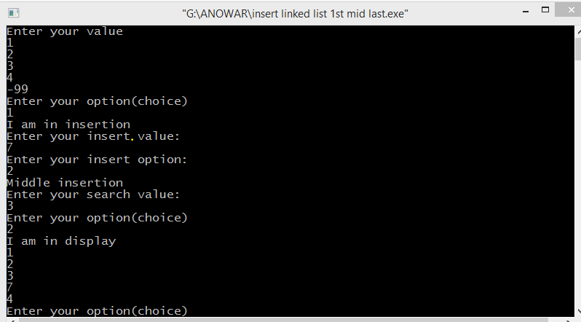

**Discussion:**

For insert a value in a linked list at first,at middle at last, first I write an algorithm ,then I write program according to it.I can insert many element by an infinity loop.Firstly I face many problem to solve this problem,then I take help from my teacher. Finally I easily solve this problem.